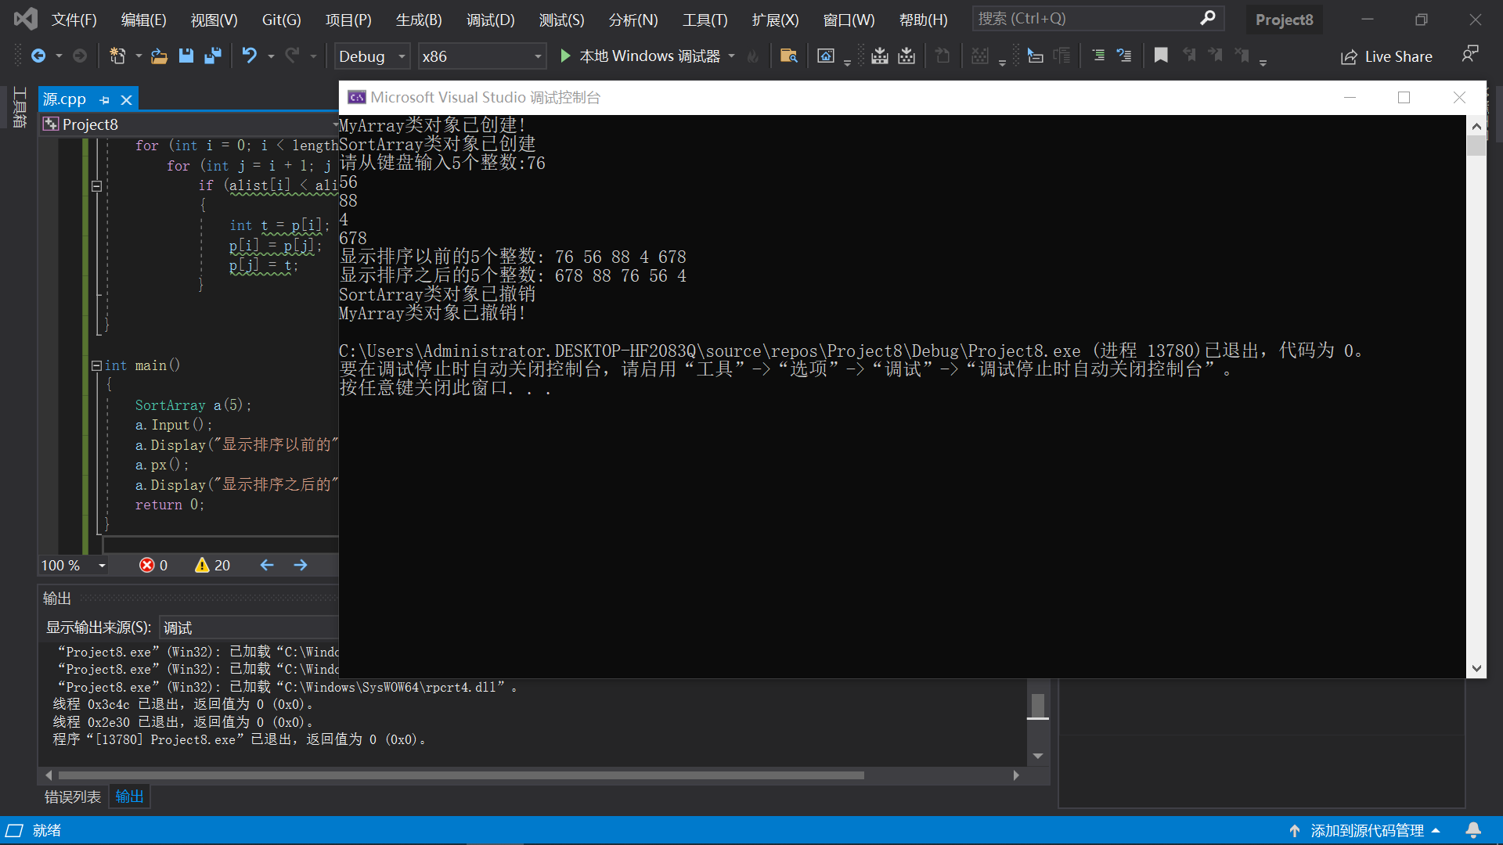include<iostream>
#include<string>
using namespace std;
class MyArray {
public:
MyArray(int length);
~MyArray();
void Input();
void Display(string);
protected:
int *alist;
int length;
};
MyArray::MyArray(int leng)
{
if (leng <= 0)
{
cout << "error length";
exit(1);
}
length = leng;
alist = new int [length];
if (alist == NULL)
{
cout << "assign failure";
exit(1);
}
cout <<"MyArray类对象已创建!"<< endl;
}
MyArray::~MyArray()
{
delete []alist;
cout << "MyArray类对象已撤销!" << endl;
}
void MyArray::Display(string str)
{
int i;
int *p = alist;
cout << str << length << "个整数: ";
for (i = 0; i < length; i++, p++)
cout << *p << " ";
cout << endl;
}
void MyArray::Input()
{
cout << "请从键盘输入" << length << "个整数:";
int i;
int *p = alist;
for (i = 0; i < length; i++, p++)
cin >> *p;
}
class SortArray :public MyArray {
public:
void px();
SortArray(int leng);
~SortArray();
};
SortArray::SortArray(int leng):MyArray(leng)
{
cout<<"SortArray类对象已创建!"<<endl;

}
{
cout<<"SortArray类对象已撤销!"<<endl;
}
void SortArray::px()
{
int *p = alist;

for (int i = 0; i < length - 1; i++)
for (int j = i + 1; j < length; j++)
if (alist[i] < alist[j])
{
int t = p[i];
p[i] = p[j];
p[j] = t;
}

}

int main()
{
SortArray a(5);
a.Input();
a.Display("显示排序以前的");
a.px();
a.Display("显示排序以后的");
return 0;}
感想心得：要理解构造函数和析构函数的被调用时的顺序，析构函数的顺序正好与构造函数顺序相反。程序结束后，系统后自动调用析构函数。此题让我了解了构造函数和析构函数的执行顺序。且用了new和delete分别创建和释放空间，同时用了指针，知识点很多，要格外认真。
Copyright ©2021-2099 PengYuRen. All rights reserved

